2. Compute training and test error of all four versions of the algorithm.

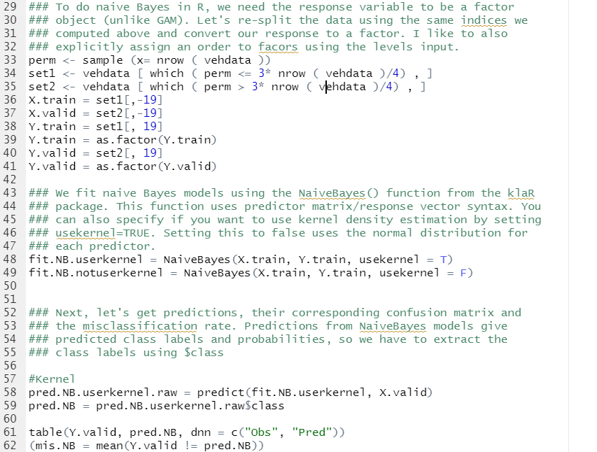

(a) **Report them in the order**

i. No PC, Kernel

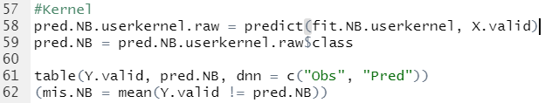



ii. No PC, Normal

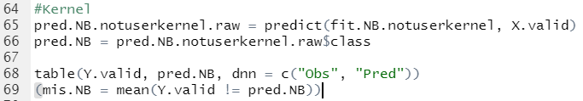



iii. PC, Kernel

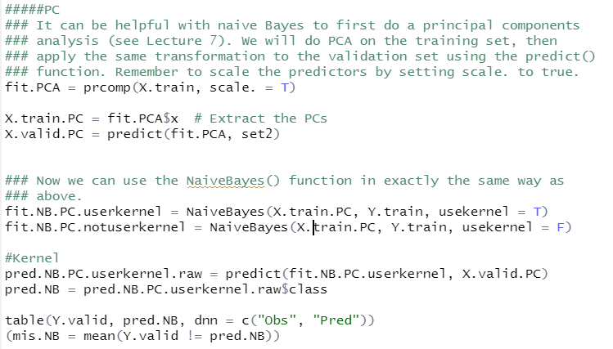



iv. PC, Normal



(b) **Comment on how the test errors compare to each other. Do PC or**

**kernel density estimation seem to help?**

Yes, the value with PC looks much lower value. The value with PC and without kernel shows the lowest value

(c) **How does test error compare to other methods?**

LDA and Qda shows the error lower than 0.2, so these cannot be the best methods.